Name: Poushali Das

Assignment(Java)

1.Hello World

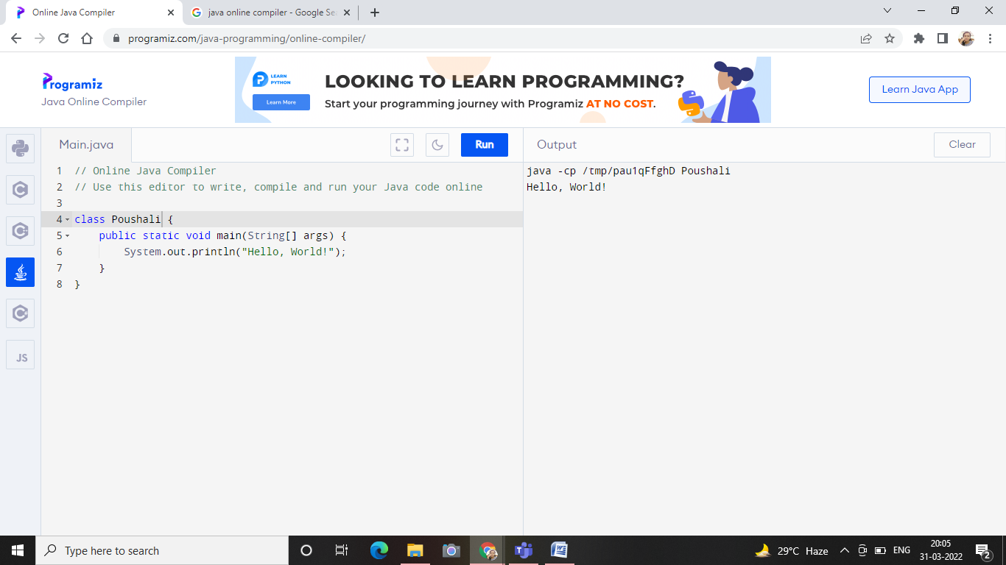

2.area

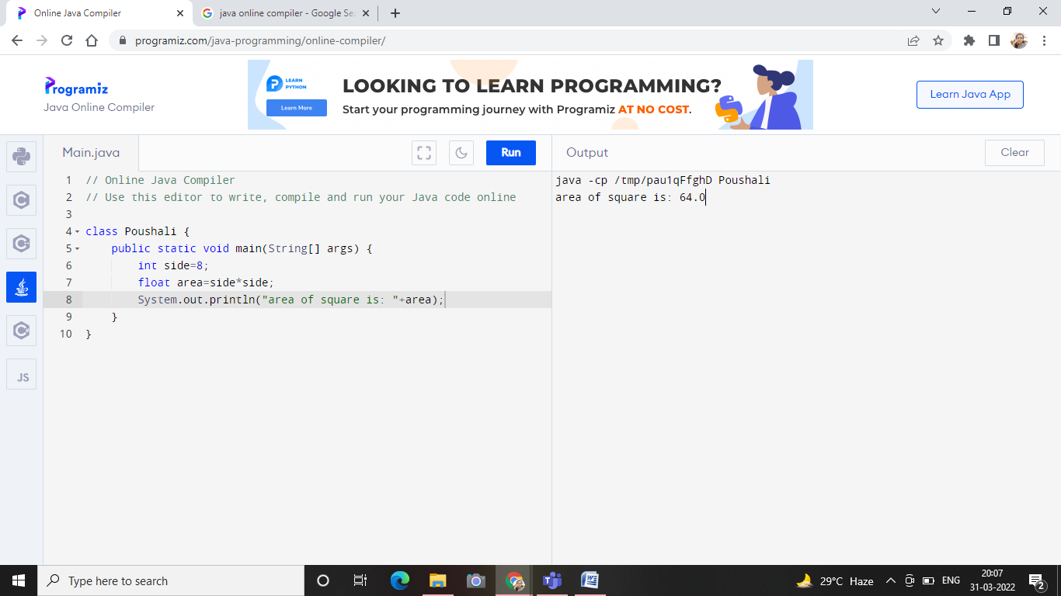

3. Arithmetic, Assignment, Comparison, Logical

4.String

